俞宁
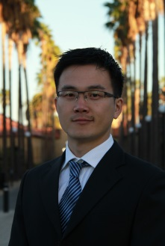

研究主任与研究员，清华-布鲁金斯公共政策研究中心
研究员，布鲁金斯学会约翰·桑顿中国中心
E-mail：NYu@brookings.edu
通讯地址：北京市海淀区清华大学公共管理学院
清华-布鲁金斯公共政策研究中心
个人网站：http://sites.google.com/site/neilningyu/

教育背景
2010-2015 斯坦福大学，经济学，硕士、博士
2001-2010 上海交通大学，管理学，学士、硕士、博士

过去任职
2015- 2016 埃默里大学经济系助理教授

论文发表
1. Yu, Ning Neil. "A Quest for Fundamental Theorems of Social Choice." Social Choice and Welfare, 44 (2015), 533-48.
2. Yu, Ning Neil. "A One-Shot Proof of Arrow’s Theorem and the Gibbard-Satterthwaite Theorem." Economic Theory Bulletin 1, no. 2 (2013): 145-149.
3. Yu, Ning Neil. "A One-Shot Proof of Arrow’s Impossibility Theorem." Economic Theory 50, no. 2 (2012): 523-25.
4. Yu, Ning, Thorsten Chmura, Thomas Pitz, and Ning Sun. "Bargaining over Perfect Complements Owned Separately: With Experimental Test." Economics Letters 107, no. 2 (2010): 115-18.
5. Yu, Ning, Qinghua Shi, and Hongtao Jin. "Permanent Land-Use Rights and Endowment Insurance: Chinese Evidence of the Substitution Effect." China Economic Review 21, no. 2 (2010): 272-81.

